**The closer the curve is to the origin, the better the performance.**

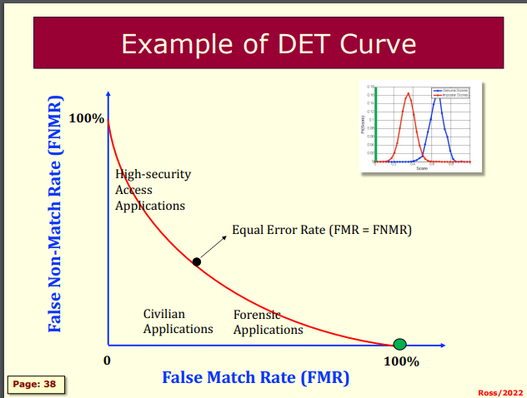

A right angle would be ideal.

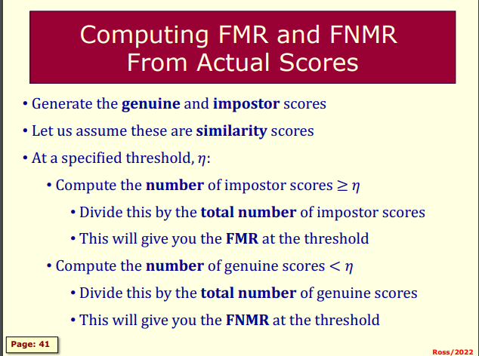

Common mistakes: someone might add up all the genuine scores instead of the proportion of the imposter or genuine scores.

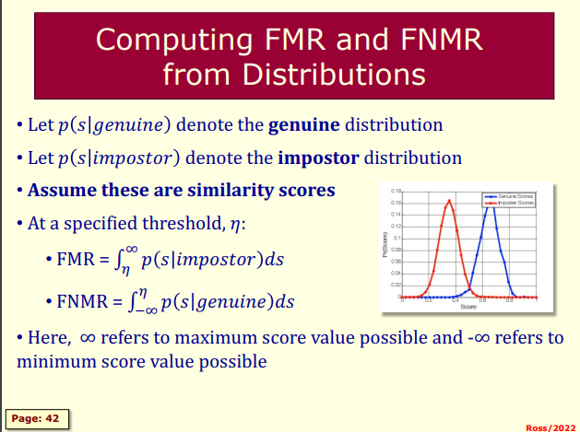

p(s|genuine) - the probability of the score being (x) give that is it genuine

p(s|imposter) - the probability of the score being (x) give that is it imposter

****Assume the opposite***  
For false match rate(fmr) for dissimilarity - limits change from -inf to n

And for fnmr - limits are form n to inf

Computing the DET Curve

* Vary the threshold n from the minimum of al score values to the maximum of al score values in increments of (delta)
* Ensure that you have at least 100 threshold values
* At each value of n computer the MFR and FNMR
* Plot these points (ie FMR, FNMR) in a graph
* This is a DET Curves

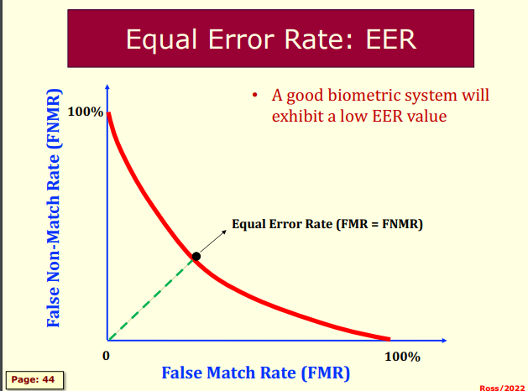

How to compute the EER?

1. Compute the point where x=y.
2. Once you have the curve.
3. Draw a line from 45deg where it intersects the graph. This point is FMR=FNMR.

FNMR @ FMR

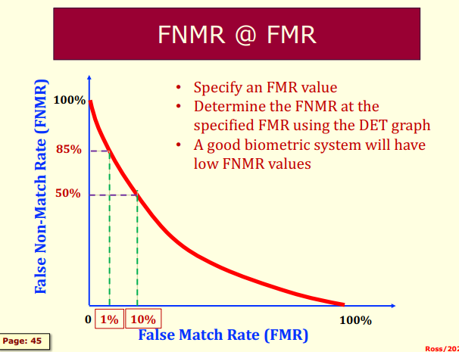

d-Prime Value: distance between the two means divided by the variance.

Function of the average of the two variances.

Higher d-prime: higher is better

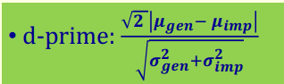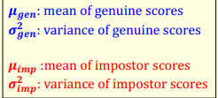

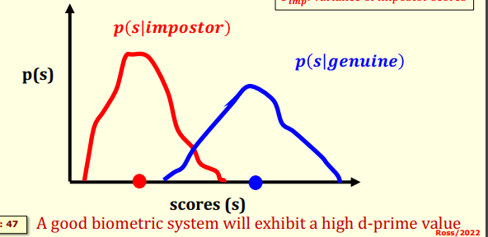

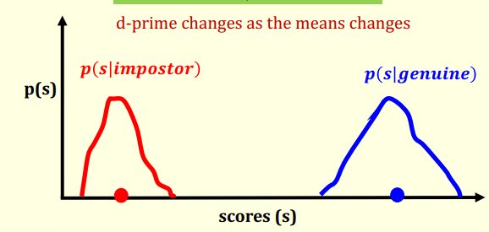

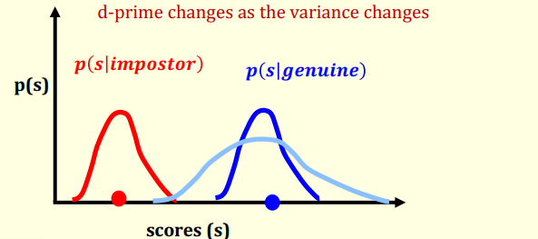

Variance - how spread out the scores are. Larger range - larger variance.

